2022 Diversity Career Fair
Hosted by the Cleveland Metropolitan Bar Association
Friday, August 12, 2022

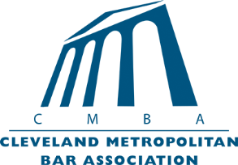

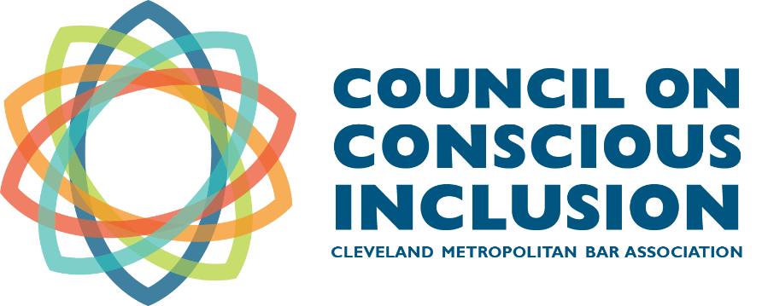

Join us at the
Cleveland Metropolitan Conference Center
1375 E. 9th Street, Floor 2
Cleveland, OH 44114

Greetings,
We cordially invite you to participate in the 2022 Diversity Career Fair. The Career Fair will be held on Friday, August 12, 2022 at the Cleveland Metropolitan Conference Center, located at 1375 East 9th Street, 2nd Floor, Cleveland, Ohio 44114.
The CMBA serves as the center for legal professionalism in Greater Cleveland and leverages the talents of its world-class legal community to serve those in need through a variety of pro bono and community service programs. Conscious Inclusion is the first of the core values of the CMBA and this includes a commitment to promote diversity and inclusion within the legal profession. Our Council on Conscious Inclusion provides oversight of the CMBA’s diversity and inclusion initiatives including the operation of several diversity workforce development programs that connect students from high school through law school into the legal profession.
The most successful legal employers recognize the importance of recruiting, developing, and retaining diverse attorneys. The 2022 Diversity Career Fair provides an excellent opportunity for employers to recruit diverse students and licensed attorneys who will become significant contributors to both the legal community and to the future success of participating employers. Candidates will express interest in employers and employers who are holding closed interviews will choose who to interview. The opportunity for open interviews and interactions will also be available. Our team is working tirelessly to organize a great event so employers may efficiently identify candidates who fit their unique work environments.
If you have any questions or concerns, feel free to contact Pegah Zardoost, Inclusion and Pro Bono Programs Specialist, at pzardoost@clemetrobar.org or 216-539-5982. We look forward to your participation in this year’s Career Fair!
Sincerely,
Gregory G. Guice and Gabrielle Kelly
Co-Chairs, Diversity Career Fair
Cleveland Metropolitan Bar Association

Registration
Candidates must register by completing the following link: https://forms.gle/oZijSGX3W4U9gZyS9

Key Dates
Wednesday, June 22: |  | Employer Registration Opens
Wednesday, July 13: |  | Employer Registration Closes
Tuesday, July 19: |  | Job Seeker Bidding Begins
Friday, July 29: |  | Job Seeker Bidding Ends
Monday, August 1: |  | Employer Selection period begins
Friday, August 5: |  | Employer Selection period ends
Monday, August 8:  Wednesday, August 10: |  | Final Interview Schedule sent to Employers  Interview Schedule sent to Job Seekers
Friday, August 12: |  | Career Fair/Interviews

August 12 - Schedule of Events
Friday, August 12: | 7:30 a.m. – 9:00 a.m. | Job Seeker/Employer Check-in Open
 | 7:30 a.m. – 9:00 a.m. | Continental Breakfast available
 | 9:00 a.m. – 12:00 p.m. | First Half of Employer Interviews
 | 12:00 p.m. – 1:00 p.m. | Lunch
 | 1:00 p.m. – 5:00 p.m. | Second Half of Employer Interviews
 | 5:00 p.m. – 7:00 p.m. | Informal Networking Reception

